**DATA SOURCES**

**NC Death Certificates**

When an individual dies in North Carolina, that event is recorded at the local county level. At the time of death, a death certificate records the primary and additional causes of death, demographic information about the deceased, identifying information about this person and where s/he/they live and the location and type of place they died. These records are then aggregated at both the local and state levels and ultimately used to inform local and state grant funding, policies, and evaluations. Importantly, when a person dies their death record becomes public record. Therefore, this data was available to us for use from the SCHS, facilitated by a request by RTI.

**Synthetic Populations (Synthpop)**

The Synthetic Population dataset was provided by RTI. As the name suggests, this is a completely synthetic dataset created to represent the entire population. This data was created based off the census and the American Community Survey (ACS). In other words, each individual in this dataset does not represent any real person. However, aggregate statistics as small as the block group level are almost identical to aggregate statistics of true population data. With this approach, we are able to protect people’s privacy as well as circumvent many approval processes for this project. Additionally, because this data is man-made, it is completely clean and has no missing data. The only outliers included in this dataset is in the income variable, which can be corrected for by truncating or binning values.

**National Survey on Drug Use and Health (NSDUH 2018)**

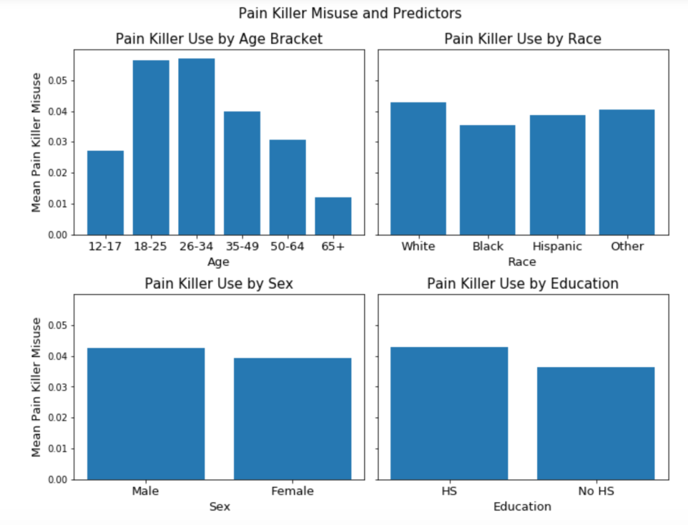Generally, [NSDUH](https://nsduhweb.rti.org/respweb/homepage.cfm) provides up-to-date information on tobacco, alcohol, and drug use, mental health, and other health-related issues in the United States. For the purposed of our project, NSDUH provides national insight into opioid use and misuse. The relationships between opioid misuse and our predictor variables is shown here.

**METHODS + RESULTS**

**Locating Local Hotpots**

Using the case definitions from the NC Department of Public Health Injury Epidemiology and Surveillance Unit, we were able to classify the cause of death for the provided NC mortality data from 2004-2016. Using geopandas, we were able to map these deaths and identify areas in Durham County with the highest opioid death rates.

